Example of Dashboard UI design and Job Search Page using React.

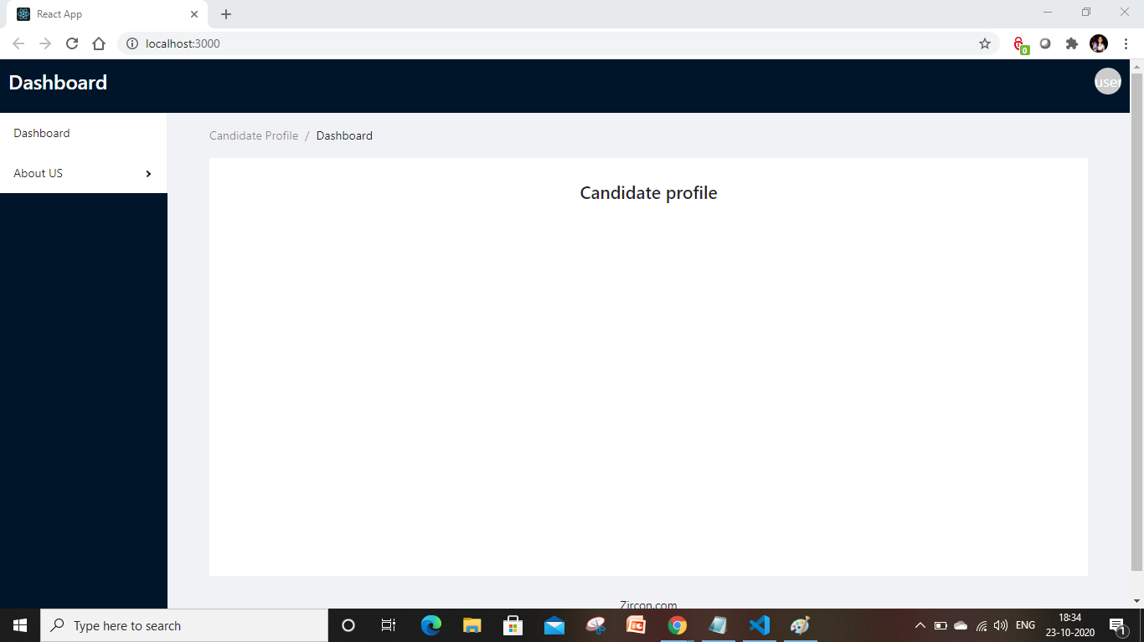

Candidate Job search page: where user can navigate jobs based upon location.

